Rewards App

DoorDash App Proposal Illistration

Monday, December 27, 2021

5:43 AM

Marketplace

DBJtissue i:



1,000,000 Bei

HDF

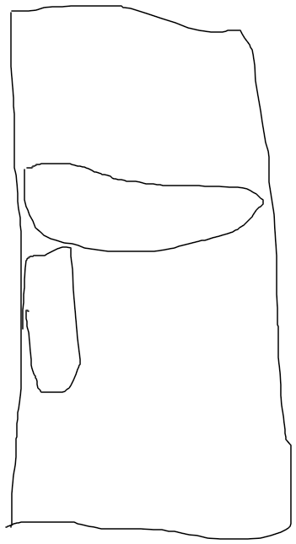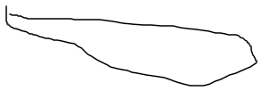

sold



Bought

r ~ -

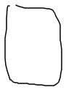

Dasher

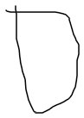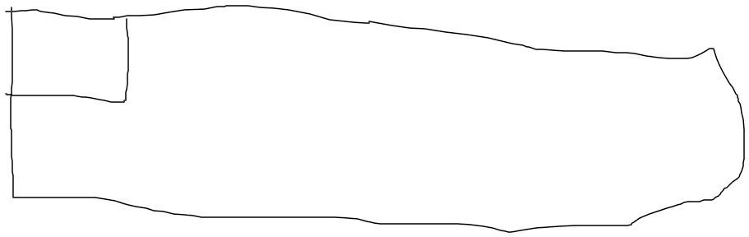

New order

Accept + $3 Antibot:

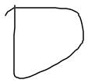

. -o

